Continuous uniform distribution

Def

A family of symmetric probability distribution.

Annotation



Parameter



Support



PDF

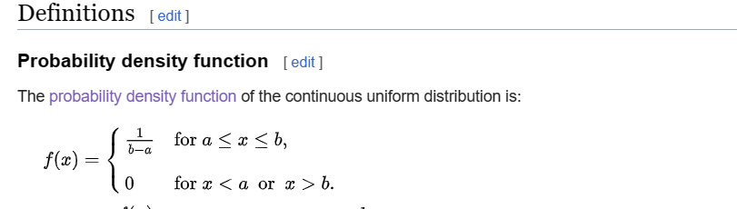

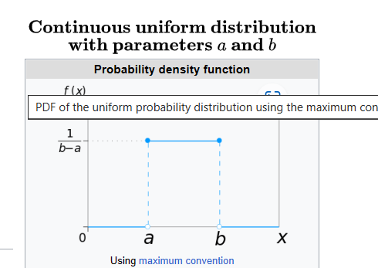

CDF

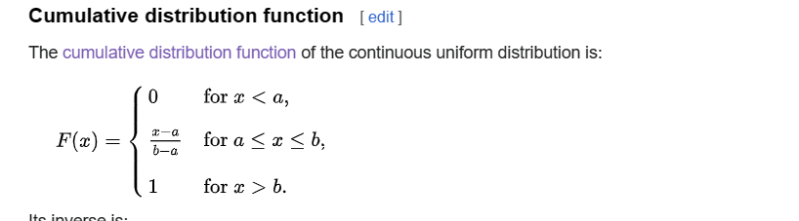

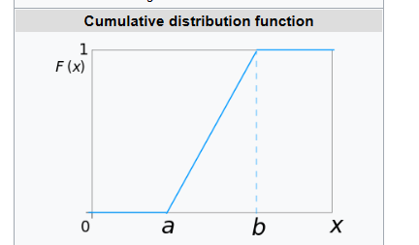

The inverse of CDF is:

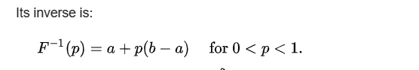

Expected Value



Variance



Median



Mode



Skewness



Ex. Kurtosis



Entropy



MGF



CF



MAD



Ref